
Financial Guardian pre-appointment information leaflet
We have recently received a copy of your application to the court to be appointed as a financial guardian. This leaflet will explain more about who we are and our role as well as give you information about the duties you may be expected to perform if you are appointed as a financial guardian.

- Who is the Public Guardian?
The Public Guardian, an official of the Scottish Courts and Tribunals Service, has been given statutory authority to supervise financial guardians. Our duty is to ensure all financial guardians act in the best interests of an incapable adult and that they carry out their duties properly.

- Duties of the financial guardian
Financial guardians hold a position of trust and must act with due skill and care when exercising their powers. It’s important that you consider if you have the time and ability to commit to the appointment. Most guardians are expected to send us an inventory of the adult’s estate, a management plan and annual account.

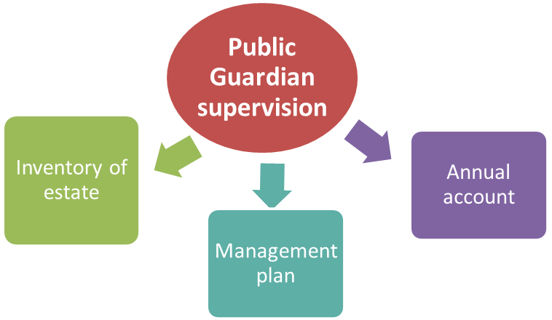
The first year of financial guardianship could be time consuming and it is important that you consider if there is anything that would prevent you being an effective financial guardian e.g.
  - health problems
  - caring responsibilities
  - work responsibilities or working patterns
  - geographical issues
  - issues with completing forms or paperwork
If you are considering becoming a financial guardian, please familiarise yourself with the administrative duties that now follow as you may be expected to comply with these. Throughout your appointment we will write to you to let you know what we need you to do.

So, what’s involved?
What is an annual account? The inventory of estate lets you tell us about all the income, assets, expenditure and debts belonging to the adult. We provide guidance and a form for you to use. A short video is available and explains how to complete the form. You will need to contact various fund holders e.g. banks, building societies, Department of Work and Pensions. You will need to send supporting information along with the inventory, such as:
bank / building society statements or a letter from them confirming the balance of any accounts held by the adult
letters or statements from benefit or pension providers
evidence of the values of any stocks / shares and or investments
evidence of any debts that existed at date of appointment



Most financial guardians are asked to complete a management plan. This lets you tell us how you intend to manage the adult’s estate for their benefit. We are looking for specific information about the adult’s day to day outgoings e.g. utilities, mortgage, rent, care costs, hobbies and holidays.
We provide you with guidance and a form so you can tell us about what you propose to do longer-term about the adult’s property and / or finances. A short video is available and explains how to complete the form. You will need to take financial advice as how best to manage the adult’s property and finances if there is more than £50,000 of moveable assets e.g. bank / building society accounts. We provide worked examples to help you understand what type of information you need to tell us.

What is an annual account? You will be expected to send us a yearly record of your financial transactions with the adult's estate. We provide a form to allow you to do this. A short video is available from the website which explains how to complete the form. When you send the form to us you will need to supporting information, such as:
bank statements covering the full period
all contract notes for the sale or purchase of stocks and shares
receipts / invoices for purchases of individual items over the value of £200
award letters from the Department of Work & Pensions / Benefits Agency
evidence that you have renewed the bond of caution

If we are unable to fulfil our supervision role because a financial guardian is not meeting the necessary requirements or not providing us with information when requested, we will go back to the court to ask the Sheriff to get involved. This could mean ordering a financial guardian to provide documentation to us or removing them from their appointment.
- Fees
We charge a fee for some of the services we provide. There are certain circumstances where you may be entitled to be exempt from paying our fees. A full list of our fees and details of exemptions and how to apply can be found on our website or by contacting us. If you decide to employ a solicitor to complete the inventory, management plan or annual account on your behalf, you will be personally liable for these expenses.

- Protecting the adult’s estate against financial loss – bond of caution
On granting a financial order the Sheriff may decide to set caution. This is an insurance bond that is designed to protect the adult’s estate against financial loss because of a guardian’s mismanagement. Your solicitor will normally make any arrangements with the caution company on your behalf. Until the bond of caution is accepted by us you will not be able to exercise any of the powers granted by the Sheriff. Further information on caution is available from our website or we can provide you with a leaflet containing the contact information of the relevant insurance companies. The cost of the bond of caution can be paid from the adult’s estate.

- Your certificate of appointment

We will issue you with an certificate of appointment when we have received confirmation that the financial guardianship has been granted, and if applicable, when caution has been put in place. You will need to print off the certificate and keep this in a safe place.

It is important that you understand that you will only have the power to gather information and investigate the extent of the adult’s estate and pay day-to-day living expenses until we have approved the inventory of estate and management plan.

Your authority, as guardian, will only begin when your inventory and management place have been approved. The certificate of appointment acts as proof of your appointment. Financial institutions, such as banks, pension providers etc. will ask to see your certificate before you can deal with the adult’s financial affairs.

- Selling or buying property on behalf of an adult
If the adult has accommodation, known as their ‘dwelling house’, and you are granted powers to sell this property, you might need to get our consent before the property is sold. This must take place prior to instructing a solicitor or estate agent. You may also need to get our consent to the sale price. A similar process exists if you have been granted powers to buy a property for the adult. Forms are available from our website along with additional information on the processes.

- Your application to be appointed as financial guardian
Now that you have this information you should consider if you still wish to be appointed as financial guardian. If any of the information provided in this leaflet causes concern, please contact us to discuss the matter further. Alternatively, your solicitor will be able to provide further advice.

If you don’t want to be appointed as financial guardian, it’s not too late.

- Alternatives to financial guardianship
You may also wish to confirm with your solicitor if financial guardianship is the least form of intervention to deal with and manage the adult’s affairs. There may be other less onerous options that may be sufficient e.g. Department of Work & Pensions Appointeeship, an intervention order, authority under the access to funds scheme or in cases where the main purpose of the guardian is to deal with Self Directed Support (SDS) or Independent Living Fund (ILF) your powers could be tailored specifically to SDS or ILF which would remove the need for is to supervise.
- Further guidance & information
We appreciate the information in this leaflet can be daunting. Please be assured that we want to make your appointment as financial guardian as easy as possible. We are on hand to help and support you throughout the lifetime of your appointment. Do not hesitate to contact us if you have any questions. While we are happy to help with general enquiries and providing guidance and support to help you complete our forms, we are unable to provide legal advice.
You might find the information on our website a useful as it covers what’s involved from the beginning of an appointment right through the end.
The Scottish Government provides a Code of Practice for guardians. These are available for download alternatively hard copies may be available on request by emailing awireform.queries@gov.scot or telephoning 0300 244 4000.
Office of the Public Guardian (Scotland) Hadrian House Callendar Business Park Callendar Road
FK1 1XR
Website: www.publicguardian-scotland.gov.uk
Email: opgorders@scotcourts.gov.uk
Tel: 01324 678300
X (Formerly known as Twitter): @OPGScotland

