Contact Details Templates

To save time when entering the details of a frequently used Sender or Attorney, a Contact Details Template can be created to store their information. This can later be used to auto-complete the appropriate fields.

Log in to EPOAR

1. Click Contact Details Templates

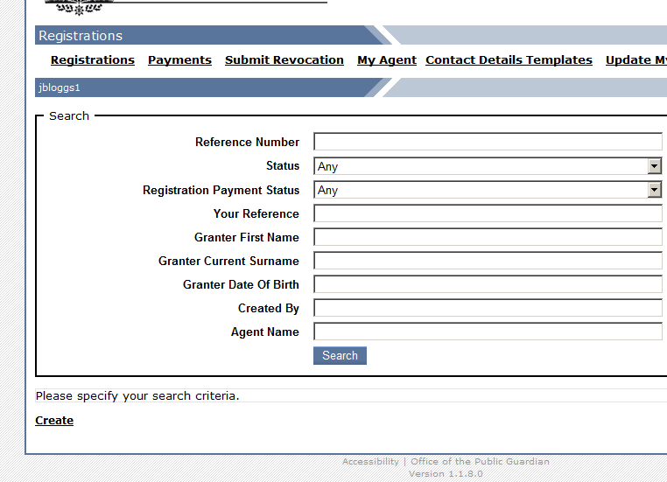

2. Click Create

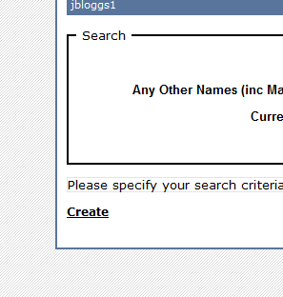

3. Insert contact details

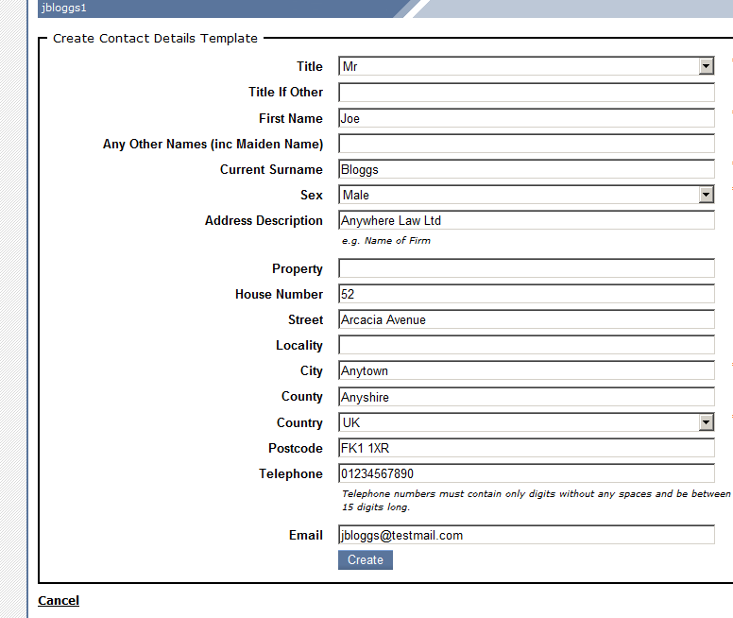

4. Click Create

